Favor Fast Centrifuge
This benchtop centrifuge for all teaching laboratory applications is CE approved. This sturdy 12-place centrifuge is supplied with a rotor that accommodates either 1.5 or 2.0 ml tubes. The motor is brushless and requires no routine maintenance. Quick-spin features, Max RPM 14,500 /Max Force 14,000g, the motor is brushless and requires no routine maintenance.

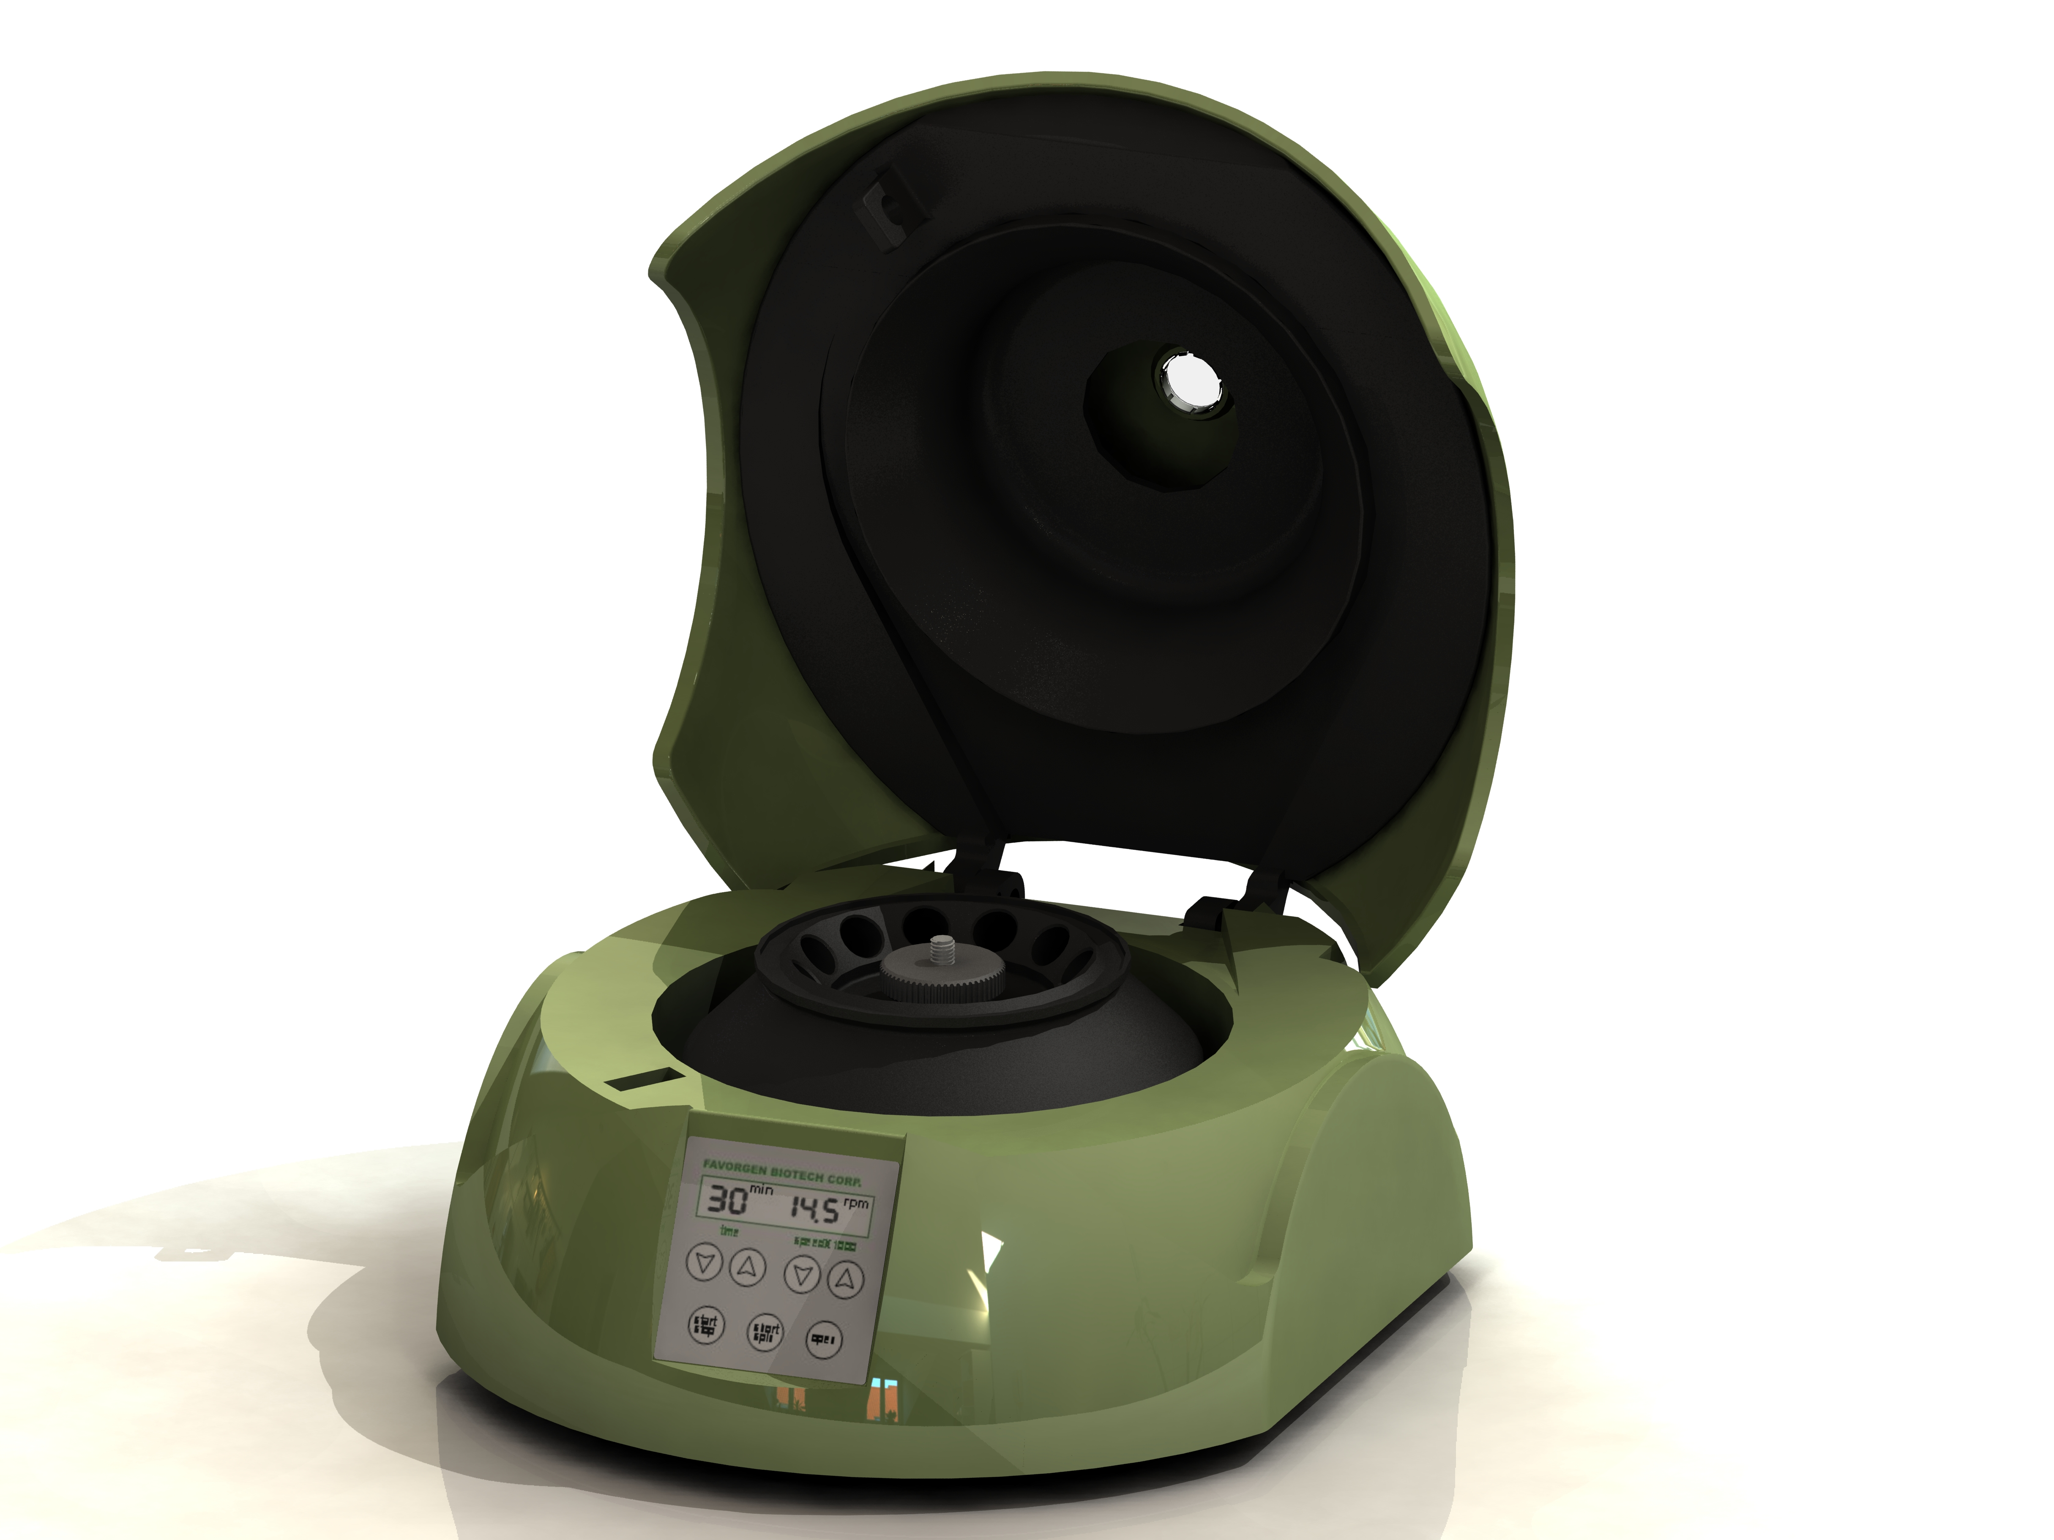

Features
- Fashion design and succinct outlook.
- Safe for cold room operation.
- Microprocessor controller with digital performance
- Fast acceleration and deceleration.
- LCD monitor.
- User Calibration.
- Quick-spin features.
- Max RPM 14,500 /Max Force 14,000g.
- Rotor could be sterilized.
- The motor is brushless and requires no routine maintenance.
- CE certification
Specification
Controller | Digital Microprocessor controller
Display | LCD
Operating Temperature | 5~35℃
Max RPM  Max Force | 14,500rpm  14,000×g
Max Capacity | 12 × 1.5/2.0ml tubes
Timer | 15 seconds ~99 minutes
Time to Max speed | 25 seconds
Time deceleration from  Max speed | 18 seconds
Ability to set by RPM, RCF, and toggle between display modes | Yes
Rated Voltages | 110V/220V selectable
Unit Dimension | W240 x L212 x H138 mm
Weight (includes rotor) | 4.5 kg
Ordering Information
Catalog # | Product Name | Max Capacity | Max Temp | Dimensions  (LxWxH)
FACTF 001 | Favor Fast Centrifuge | 12 × 1.5/2.0ml tubes | 5℃ ～ 35℃ | 212mm×240mm×138mm

